MNS-QT331 Infrared methane gas sensor
Product Description
The MNS-QT331 infrared methane gas sensor utilizes the non-dispersive infrared (NDIR) principle to detect methane gas present in the air. The sensor exhibits excellent selectivity, is oxygen-independent, and boasts stable and reliable technical parameters, along with a long product lifespan. It also features a built-in temperature compensation function.
The MNS-QT331 infrared methane gas sensor utilizes infrared spectral absorption technology. It features a built-in micro precision gas circuit, crafted through meticulous post-processing, along with exquisite circuit design and precise academic algorithms to ensure accurate and stable signal data collection from the sensor. The product is easy to use and has a lifespan of over 5 years.
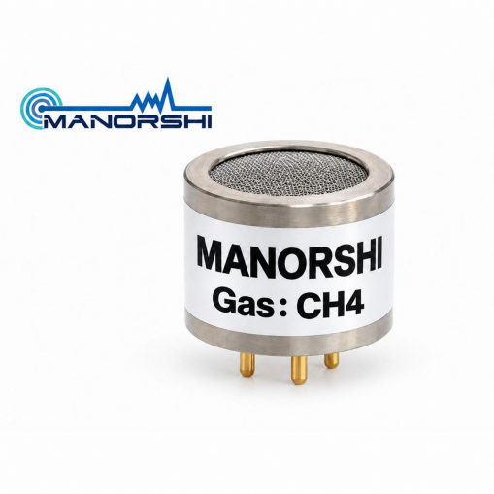

Key Features
◆ High sensitivity, high resolution, low power consumption, and fast response time
◆ Provides multiple output modes such as UART and analog voltage
◆ Temperature compensation, excellent linear output, superior stability, and long service life
◆ Resistance to water vapor interference and poisoning
◆ Use in online monitoring of industrial instruments
◆ Monitoring of gas power generation equipment
◆ Monitoring and use of industrial pipe gallery

Main applications
◆ Detection of flammable and explosive gases

Technical specifications
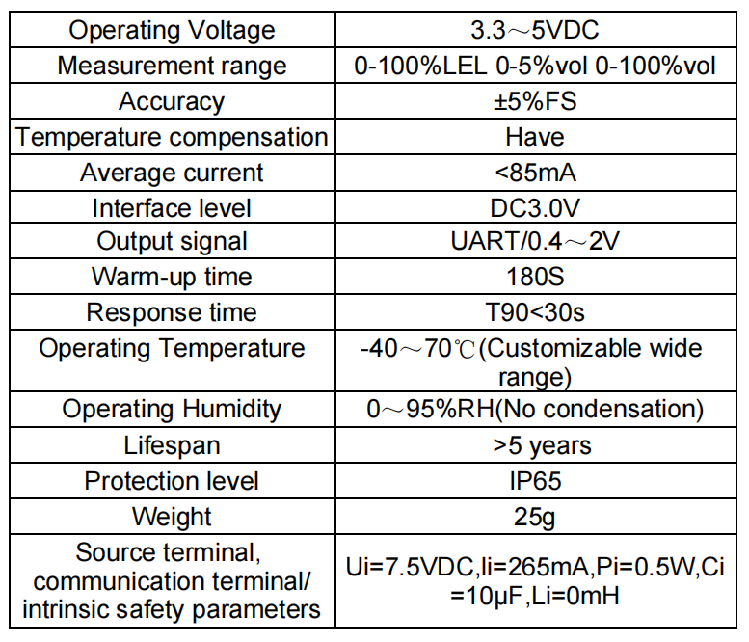

Structural dimensions（Unit：mm）
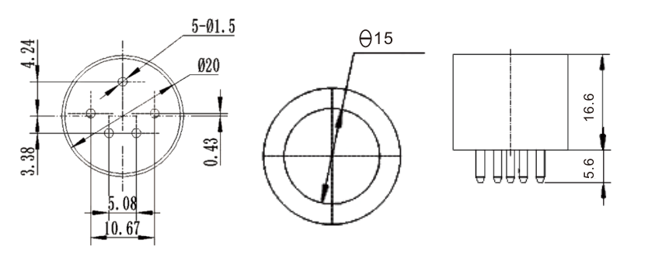

Pin definition
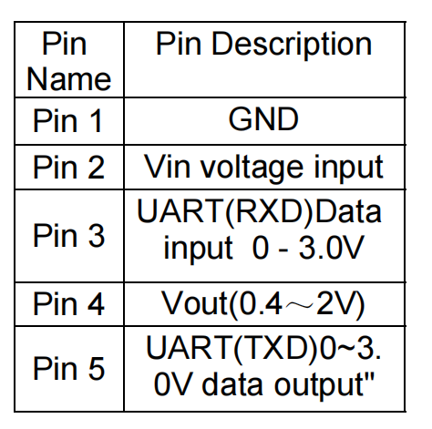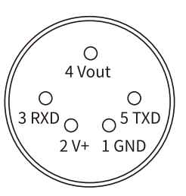

Usage Diagram

